Wheel Recommendations for URC



What we’re looking for

Recommendations

Studies

Previous designs

Curiosity rover wheels

Model

Simulation & Analysis

McGill University Rover (Bare-bones)

Model

Simulation & Analysis

Apollo LRV

Explorer USGS

Grover USGS

Sojourner

MER (Spirit/Opportunity)

Model

Simulation & Analysis

JSC’s AEVATD Lab

Convex vs Flat

Width of Wheel

Grousers

Grousers vs. Cleats

Inflatable vs. Metal wheel

Spokes

Design ideas

Design #1 v0.1

Parameters

Main wheel

Additional features

Design #1 v0.1

Bloopers

# 

# **What we’re looking for**

1. Traction on different terrain
   1. Low slip
   2. High tractive efficiency
   3. Low sinkage
   4. High drawbar pull
2. Stability
3. Durability
4. Ease of manufacturing
5. Budget-friendly

# Recommendations

1. **A six-wheeled configuration is to be given preference.** Cost and weight vs stability is effectively optimized at the six-wheeler. Four wheels cannot allow an implementation of the Rocker-bogie, and eight or more wheels simply add more to weight and cost than to stability.
2. Grousers or cleats are a must. Most designs evaluated have such features, which improve traction significantly.

# Studies

1. Previous designs
2. Convex vs Cylindrical
3. Width of wheel
4. Grousers
5. Grousers vs. Cleats
6. Inflatable vs. Metal and other wheel types
7. Spokes
8. Design ideas

# Previous designs

## Curiosity rover wheels

### Model

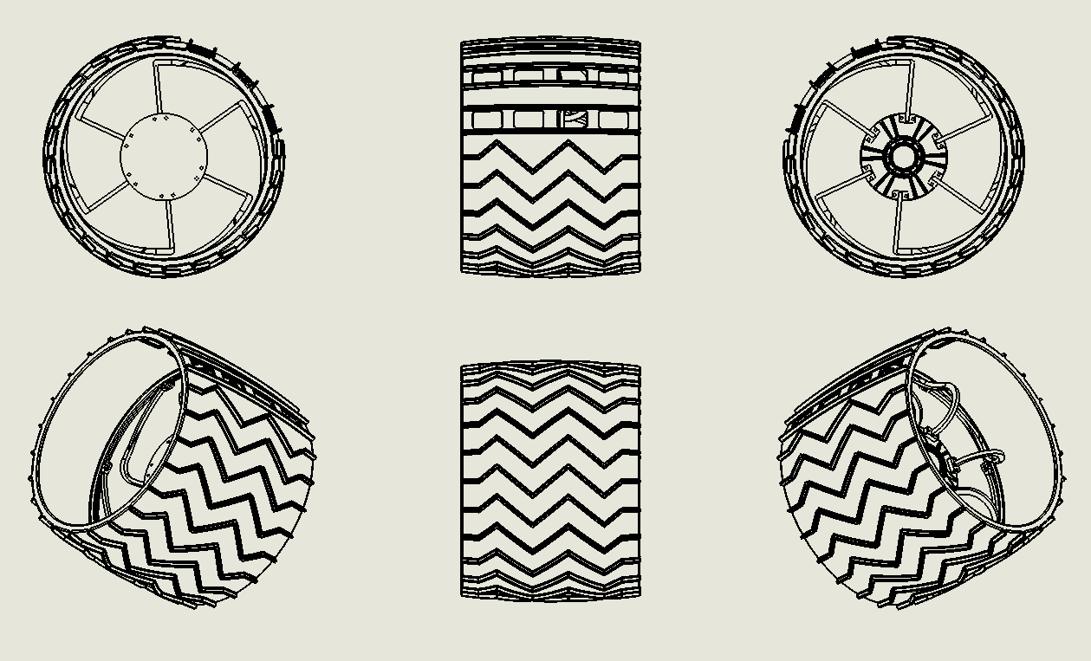

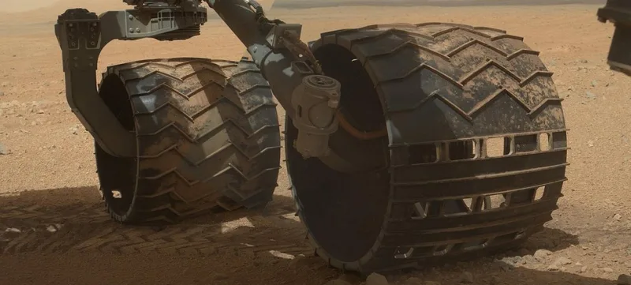

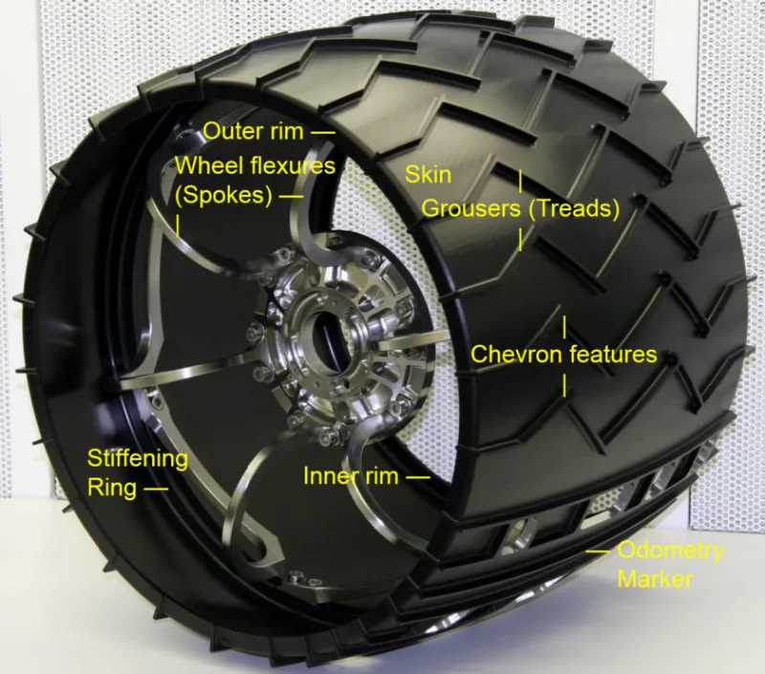

### Simulation & Analysis

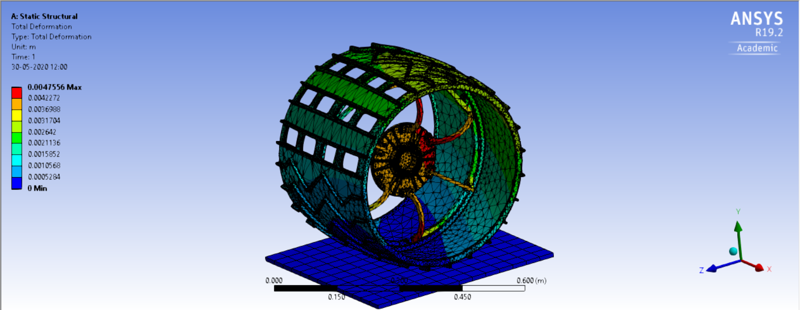

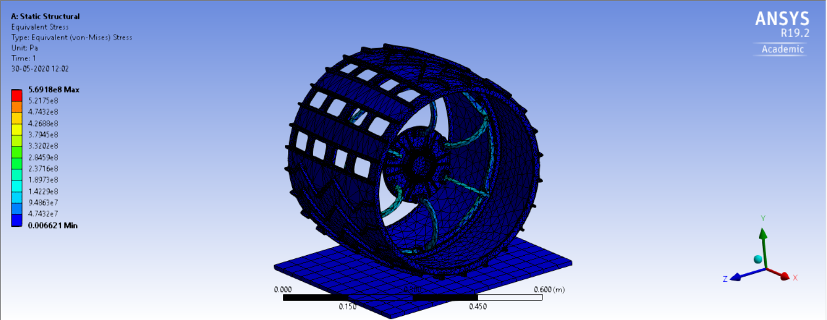

**Description**: A load of $1650 N$ (-y direction) was applied to the central shaft bearing surface, in the presence of gravity ($9.8 m/s^{2}$, in -y direction). Plane under the wheel is a fixed support.

**Body description**: Wheel surface diameter: [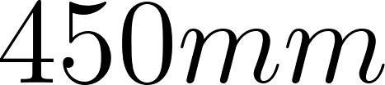](https://www.codecogs.com/eqnedit.php?latex=450%20mm#0)

Outer cylinder material: aluminum alloy (Ansys General Materials)

Spokes material: Structural steel (Ansys General Materials)

Central disk material: Structural steel (Ansys General Materials)

**Results**: Wheel deals with loading very well. Stress is developed mainly in the spokes (peak at 5.6918e+008 Pa), which are flexible and take significant deformation as seen in the first figure. 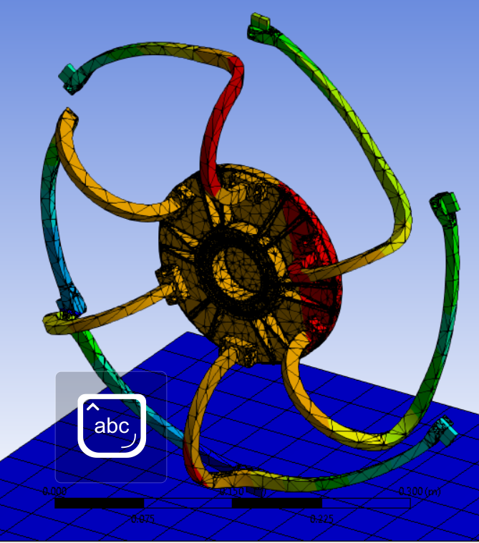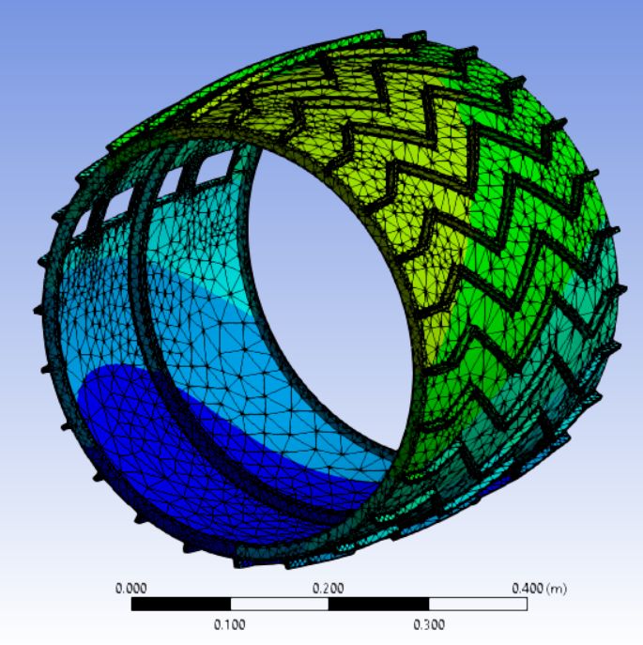

*Von mises stresses for spokes* *Equivalent deformation for outer cylinder*

The outer cylinder also takes significant deformation while being almost free of pronounced stresses. Jerk transmitted to the rover body during traversal of undulating terrain is reduced.

Overall, the design is a proficient and durable one. Since SOL 411, there have been reports and images of the front and middle wheels experiencing damage in the form of punctures in the outer cylinder [[A1]](https://gizmodo.com/curiositys-wheels-are-falling-apart-and-how-we-can-sol-1626826935) [[A2]](https://www.sciencedirect.com/science/article/pii/S0022489816300891), but this was noticed to be a pronounced damage only after SOL 488 (~500 Earth days). So, for the purposes of URC, this does not qualify as a concern.

**The outer cylinder must be made of a seamless piece of metal,** to decrease scar mass. JPL was able to accomplish this by using a single block of aluminum and laser cut-extruding it [[A3]](https://books.google.co.in/books?id=1npTDwAAQBAJ&pg=PA166&lpg=PA166&dq=curiosity+wheel+single+block+of+aluminium&source=bl&ots=H-bVupWjlX&sig=ACfU3U1KR7yy8QDt5Y1KbEGJuzSvqD6Omw&hl=en&sa=X&ved=2ahUKEwjKh_bCgdvpAhVRAHIKHdIgAp4Q6AEwAnoECA0QAQ#v=onepage&q=curiosity%20wheel%20single%20block%20of%20aluminium&f=false). This may not be within our capabilities of execution. The spokes have also been noted to be complicated parts to manufacture.

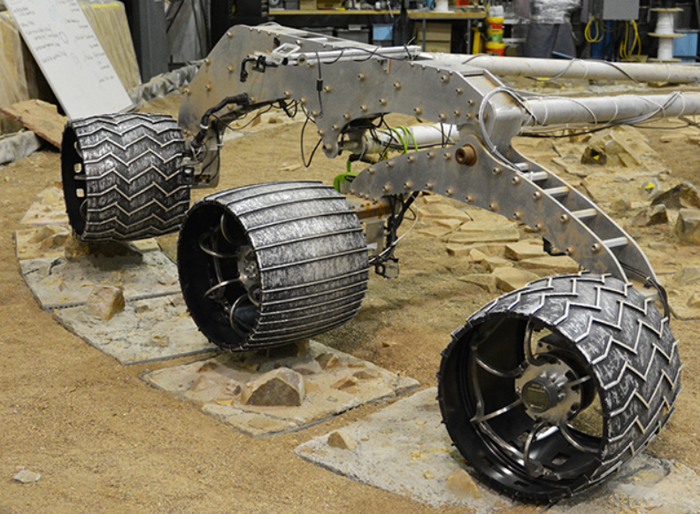

The grousers on the final MSL rover (the rightmost wheel in the photograph above) are significantly different from those on the planned Perseverance rover, whose wheels do not feature concavity (unlike MSL), and employ wavy grousers (unlike MSL’s hard-edged grousers).

***Solidworks model:***[Taken from the internet](https://grabcad.com/library/wheel-assembly-8), courtesy GrabCad user [thorfynn](https://grabcad.com/thorfynn-1)

## McGill University Rover (Bare-bones)

### Model

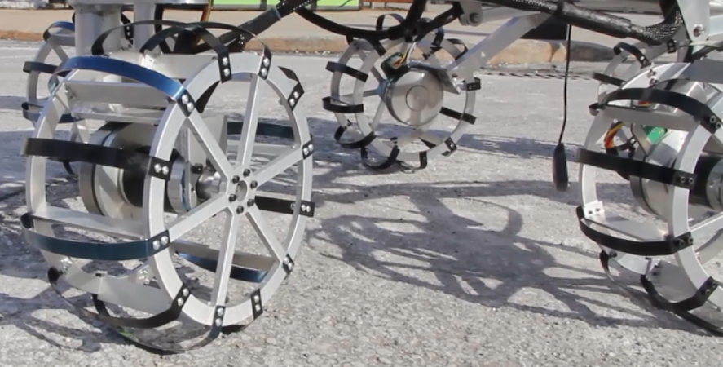

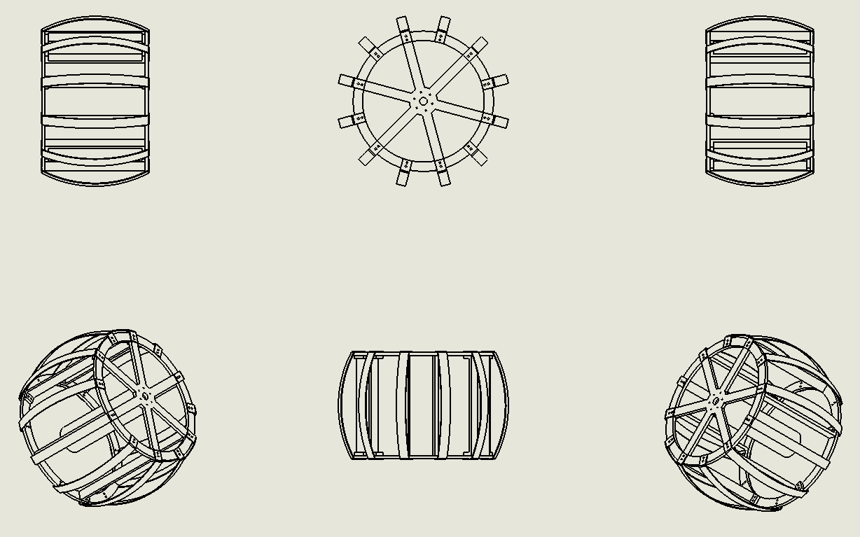

***Solidworks model:***Self-made. [Link to model](https://drive.google.com/file/d/1nAzYnFMxWbI2Ep7EvqVNzZrLOEyfbS-T/view?usp=sharing)

### Simulation & Analysis

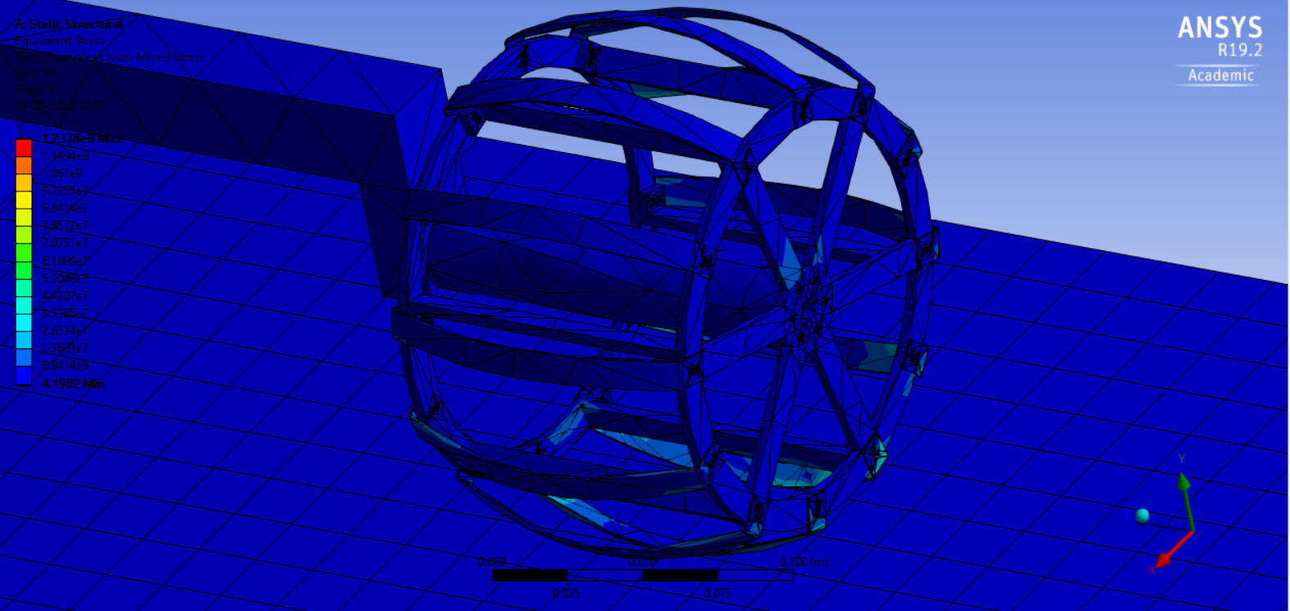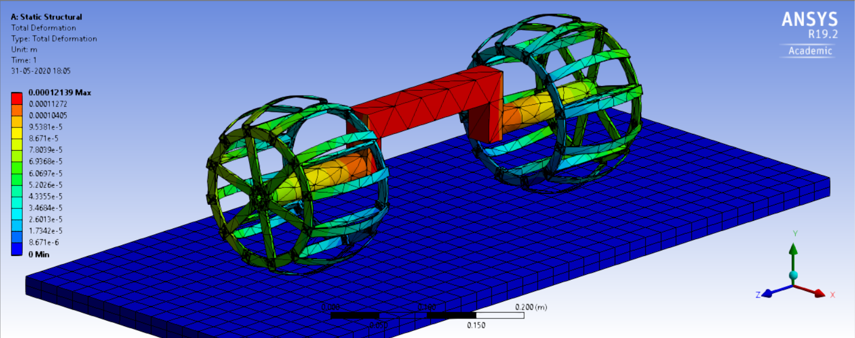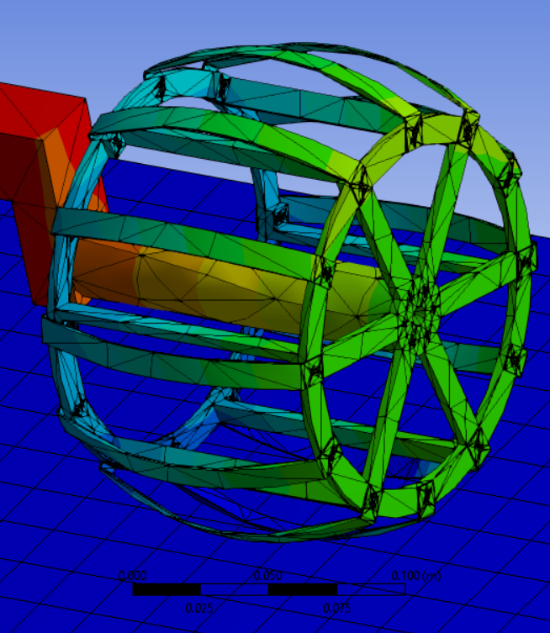

*Clockwise, from top:* Equivalent deformation; A closer look at a wheel viewing equivalent deformation; Von-mises stress developed in wheel

**Description**: A load of $200 N$ (-y direction) was applied to the upper face of the central rectangular beam which links the two wheels, in the presence of gravity ($9.8 m/s^{2}$, in -y direction). Plane under the wheel assembly is a fixed support.

**Body description**: Wheel surface diameter: [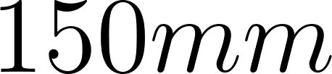](https://www.codecogs.com/eqnedit.php?latex=150%20mm#0)

All materials: Structural steel (Ansys General Materials)

**Comments:** It was unfortunately impossible to simulate the wheel assembly as such and needed conversion to a singular part which disabled the assignment of different materials to different parts.

**Results**: Stresses upon loading mostly develop in the strips in contact with the ground, and a reasonably small stress appears in the spokes of the outer rim.

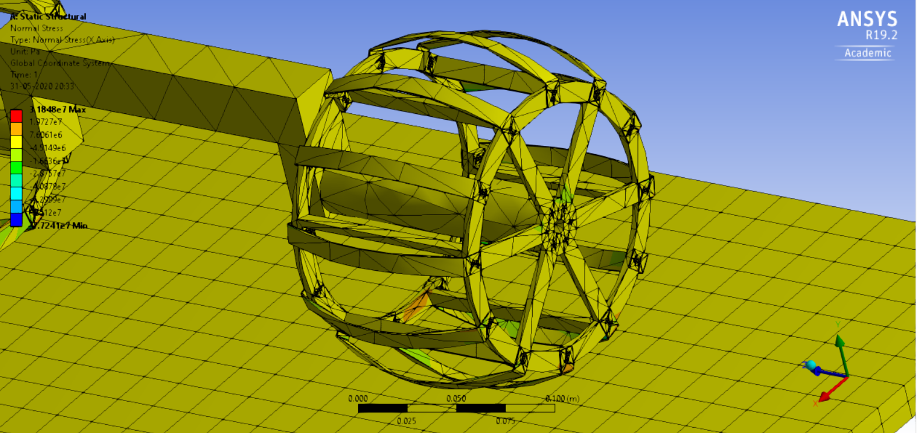

The above figure is indicative of highest normal stresses experienced by the inner rim and the rim-strip joints closest to the ground.

This design is significantly easy to manufacture, and involves easily reproducible and replaceable parts. The material volumes required are low compared to other designs of similar designs, and considerably higher can be invested in material quality while maintaining the same budget.

## Apollo LRV

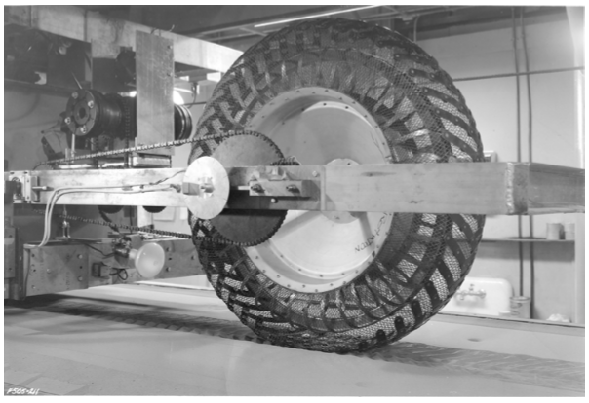

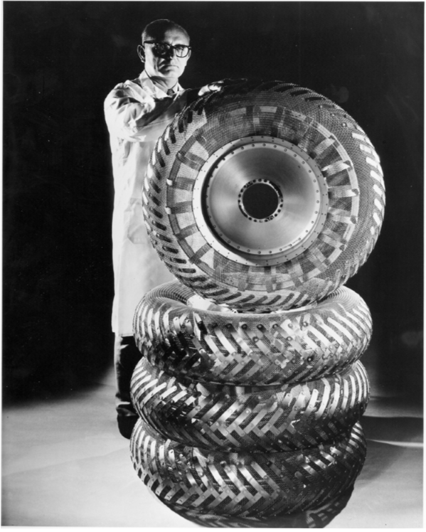

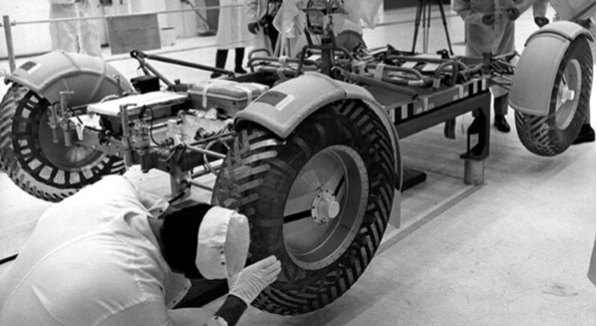

## Explorer USGS

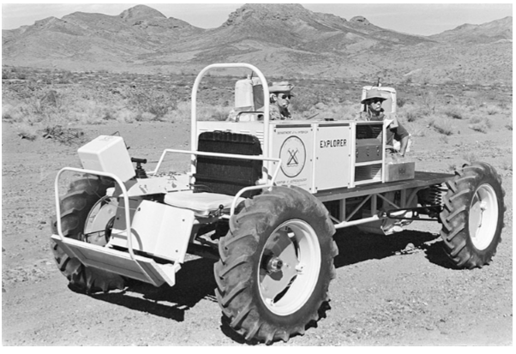

## Grover USGS

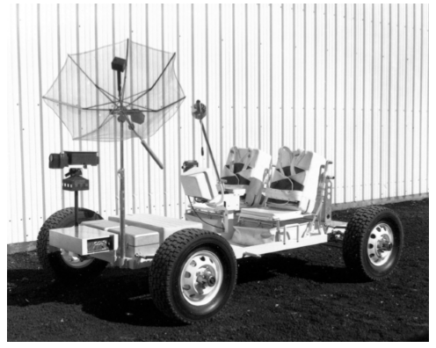

## Sojourner

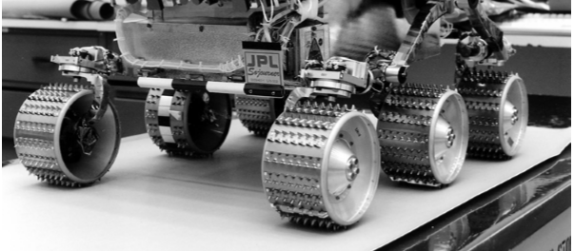

Several thousand cleats on Sojourner’s wheels.

## MER (Spirit/Opportunity)

### Model

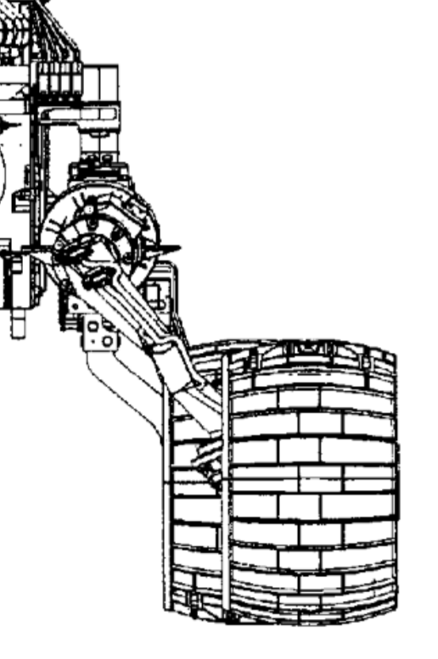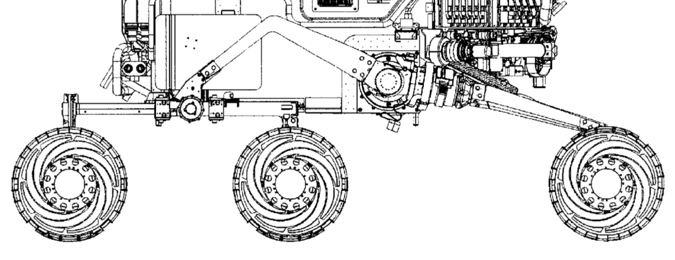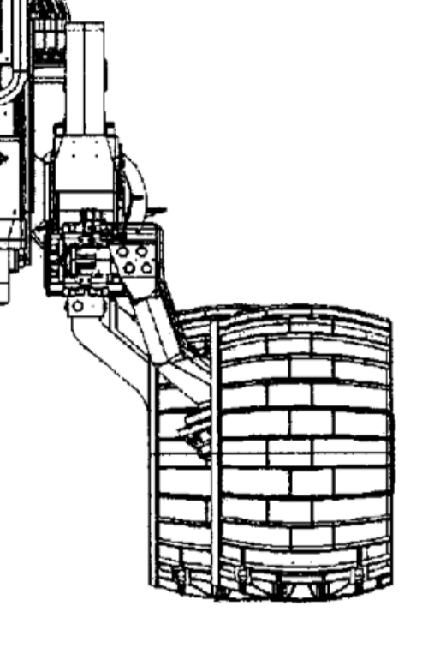

The majority of the wheel’s framework was fashioned from a single piece (billet) of aluminum [[G1]](https://www.youtube.com/watch?v=rMF3ldfc39A) [[G2]](https://www.nasa.gov/vision/universe/roboticexplorers/rover_wheels.html), for similar reasons as the MSL rover. A study of the performance history reveals that the design was not very effective in traversing yielding patches of soil, and high wheel slip and sinkage.

***Solidworks model:*** self-made. [Link to model](https://drive.google.com/file/d/1nAzYnFMxWbI2Ep7EvqVNzZrLOEyfbS-T/view?usp=sharing)

## Simulation & Analysis

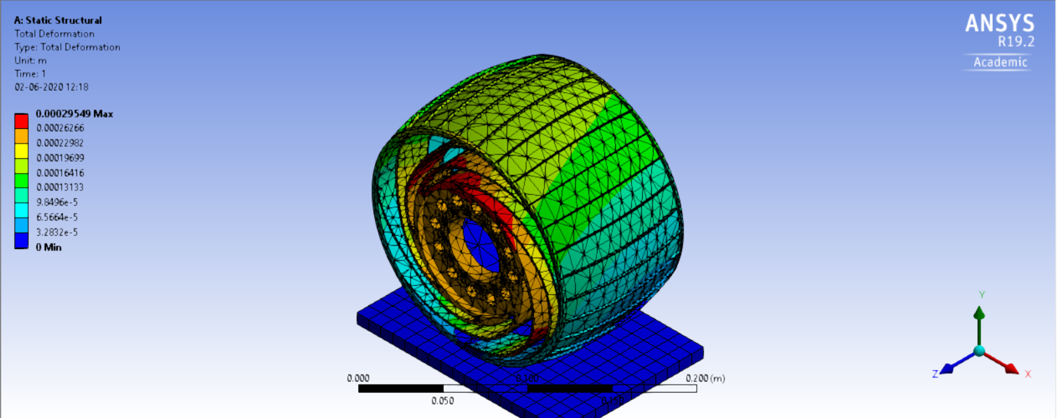

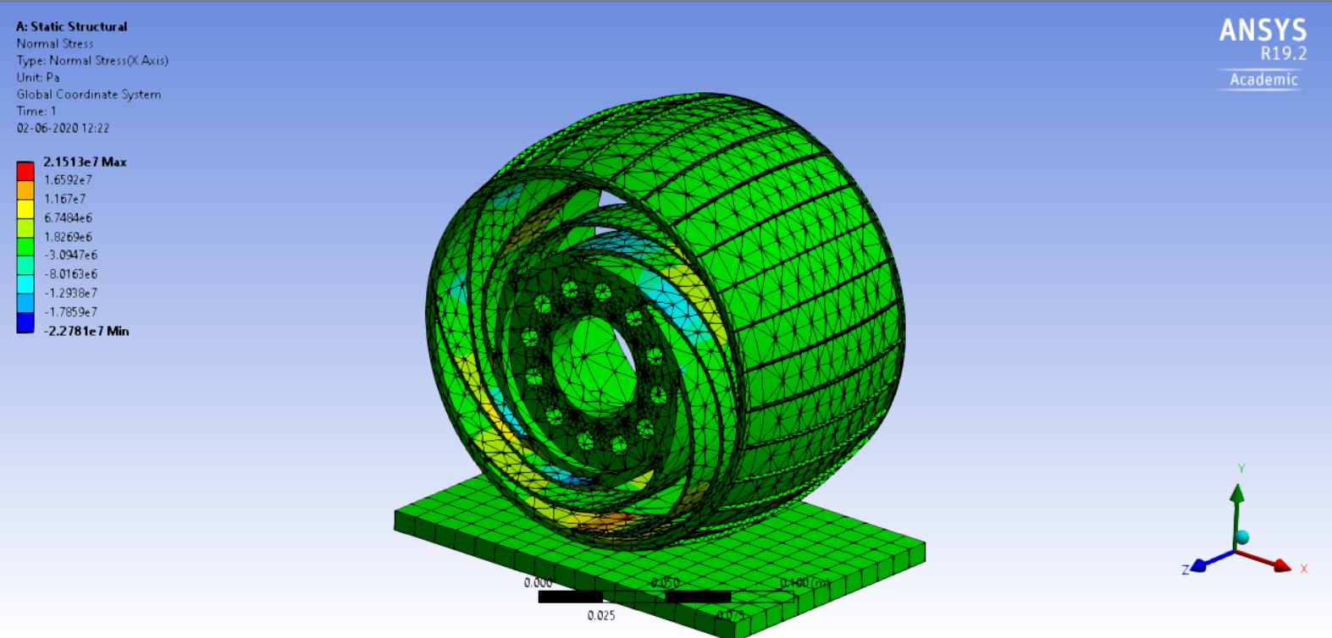

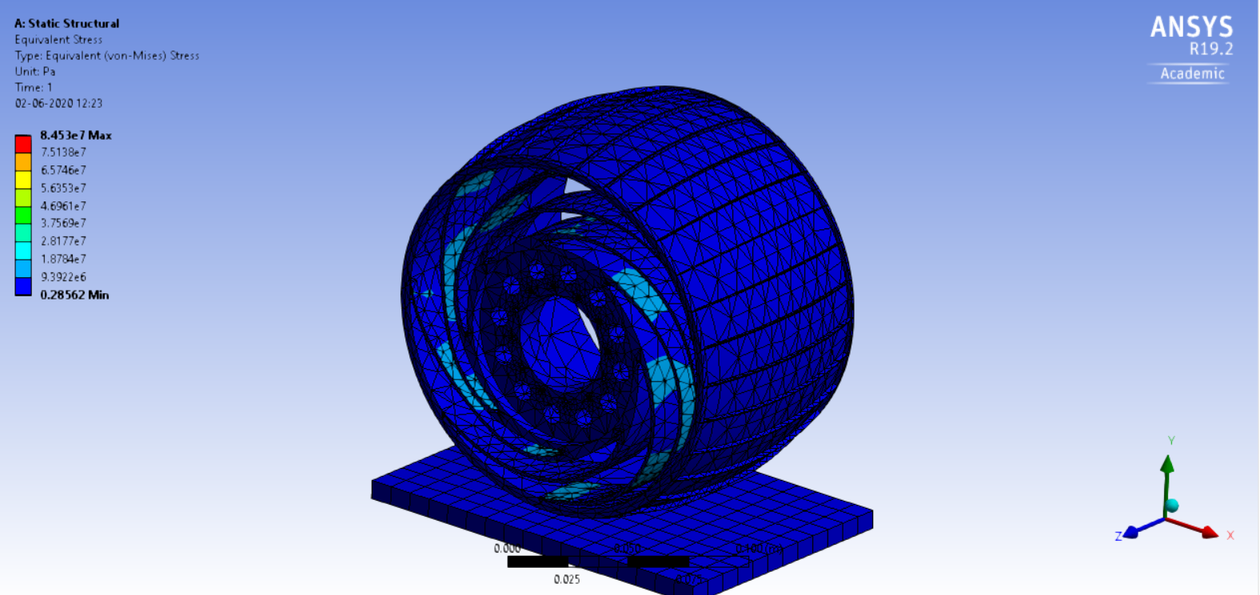

**Description**: A load of $100 N$ (-y direction) was applied to the inner bearing surface of the wheel shaft, in the presence of gravity ($9.8 m/s^{2}$, in -y direction). Plane under the wheel assembly is a fixed support.

**Body description**: Wheel surface diameter: [](https://www.codecogs.com/eqnedit.php?latex=150%20mm#0)

All materials: Aluminum Alloy (Ansys General Materials)

**Comments:** This was a simulation of the single-piece aluminum wheel body.

**Results:** The springy spoke-like links between the central hub and the outer cylinder take significant deformation and absorb impact.

## JSC’s AEVATD Lab

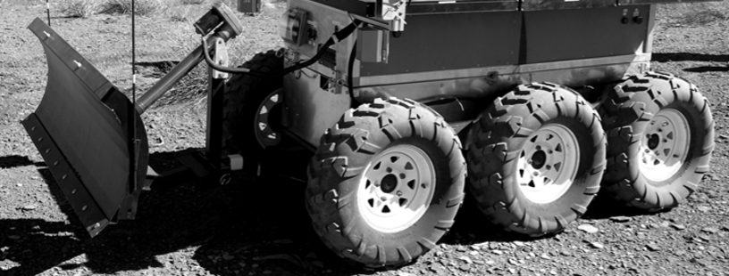

# 

# Convex vs Flat

Status: ongoing

*This study is inspired by the discussion between myself and JSS.*

Simulation has been conducted on Ansys (both profiles have the same material: Aluminum Alloy). A loading of $100 N$ was applied in the -y direction at the top-most point of the exterior wheel surface. The images below display (in order) the a. Equivalent stresses; b. Normal stresses; and c. Shear stresses.

The convex profile shows approximately the same maximum stresses at different angles from the center of the wheel, but the distributions are widely different. The regions on which the same magnitude of stresses act are smaller in the convex profile. This might be seen as a reason for the convex being a better design.

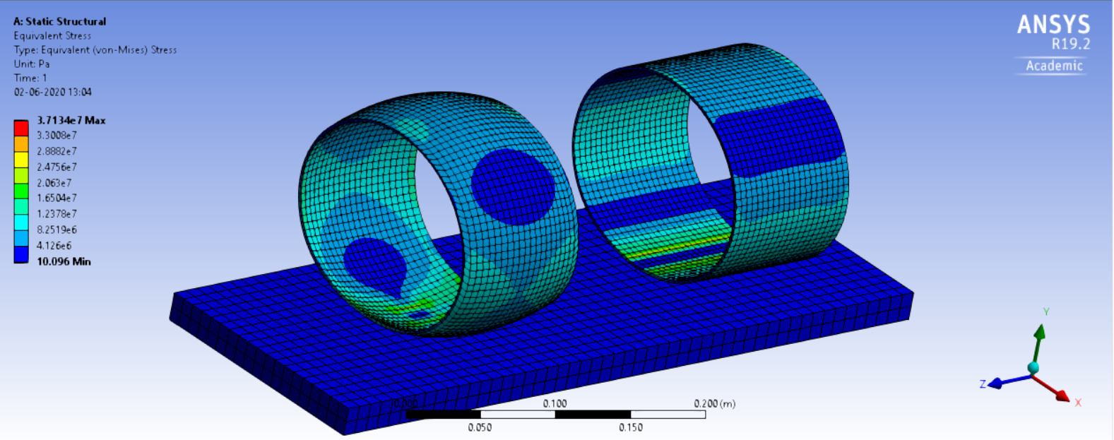

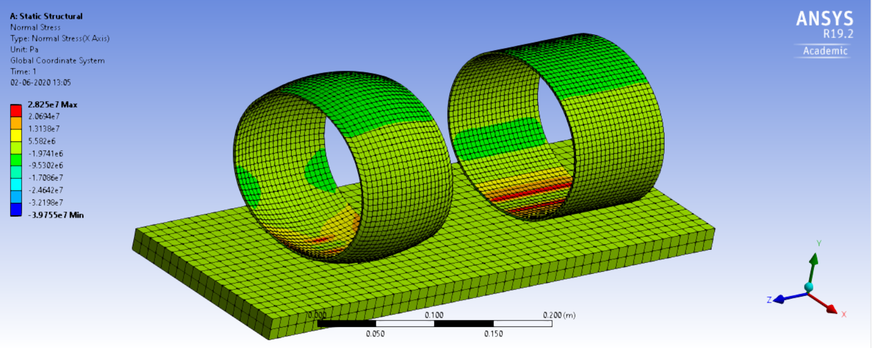

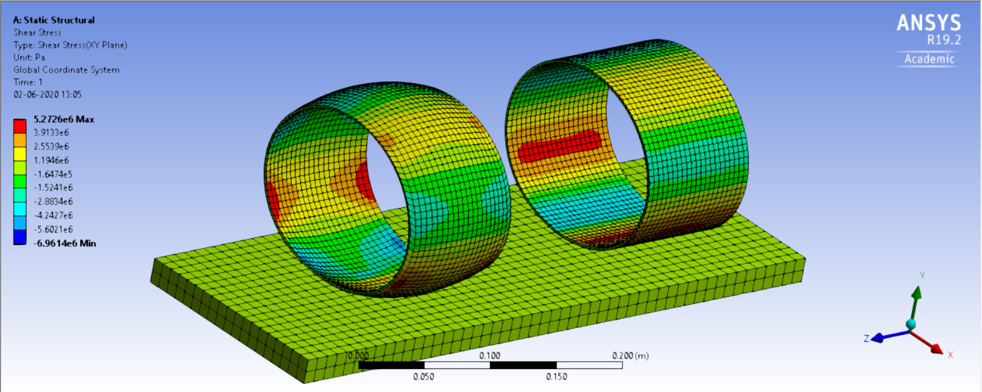

# Width of Wheel

Status: ongoing

*This study is inspired by the discussion between myself and CRK*

An interesting thing to note would be that MSL’s wheels were quite wide (~40 cm), while Perseverance had a decreased width but an increased diameter.

# Grousers

Status: ongoing

*This study is inspired by* [*a paper*](https://www.ri.cmu.edu/pub_files/2014/6/i-SAIRAS2014_Hiroaki_grouser.pdf) *shared by SM*

Rover wheels have to deal with yielding soil, regolith and is prone to wheel slip and sinkange. Grousers help with traction and decrease slip.

However, the **spacing between grousers, and their count**, have a huge weightage in determining the effectiveness of the wheel, along with other factors like **grouser height.**

Evaluation criteria, as previously mentioned briefly, is reiterated below, more explicitly:

1. Drawbar pull vs slip characteristics

[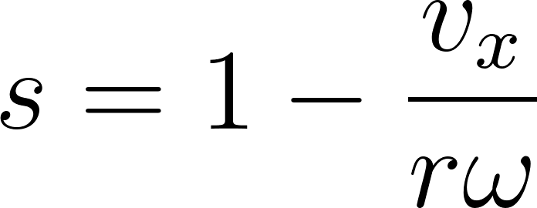](https://www.codecogs.com/eqnedit.php?latex=s%3D1-%5Cfrac%7Bv_x%7D%7Br%5Comega%7D#0)

1. Tractive efficiency

[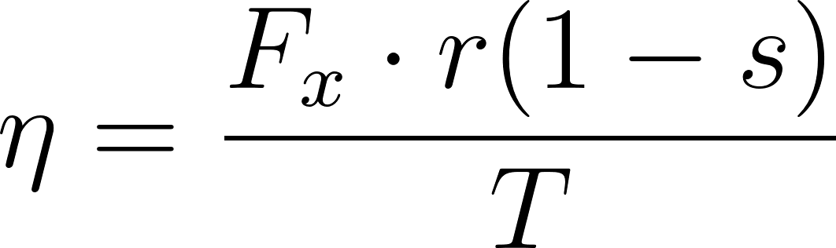](https://www.codecogs.com/eqnedit.php?latex=%5Ceta%3D%5Cfrac%7BF_x%5Ccdot%20r(1-s)%7D%7BT%7D#0)

1. Drawbar pull (Net tractive force) [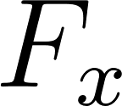](https://www.codecogs.com/eqnedit.php?latex=F_x#0)
2. Sinkage [](https://www.codecogs.com/eqnedit.php?latex=z#0)
3. Sideslip

[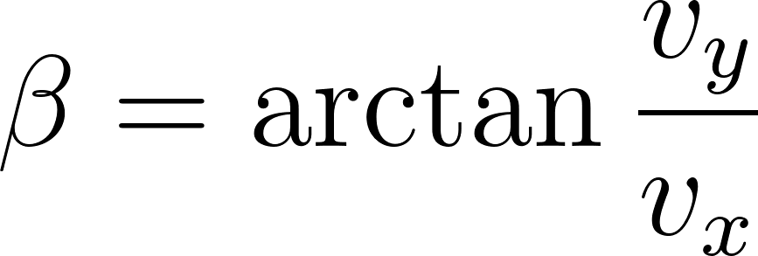](https://www.codecogs.com/eqnedit.php?latex=%5Cbeta%3D%5Carctan%7B%5Cfrac%7Bv_y%7D%7Bv_x%7D%7D#0)

The controllable parameters are:

1. Height of grousers [](https://www.codecogs.com/eqnedit.php?latex=h#0)
2. Pitch (if necessary) [](https://www.codecogs.com/eqnedit.php?latex=%5Cgamma#0)
3. Profile of grousers
4. Grouser spacing angle [](https://www.codecogs.com/eqnedit.php?latex=%5Cphi#0)

Number of soil grousers is seen to be important. In soil flow experiments, forward soil flow has been observed when insufficient grousers are used. The flow was observed to be periodic, starting when the rim comes in contact with soil before the grouser enters the soil and stops after it has entered it completely.

A higher number of grousers continuously excavates soil and thus does not allow such a flow.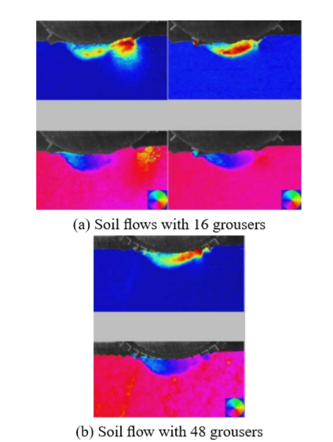

This flow of soil offers more motion resistance to the wheel and decreases drawbar pull.

[Grouser spacing equation:](https://ieeexplore.ieee.org/document/6386203)

[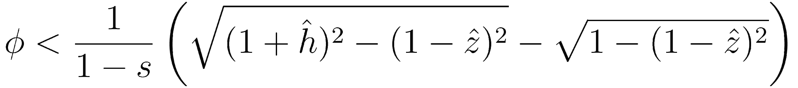](http://www.sciweavers.org/tex2img.php?bc=Transparent&fc=Black&im=jpg&fs=100&ff=modern&edit=0&eq=%5Cphi%20%3C%20%5Cfrac%7B1%7D%7B1-s%7D%5Cleft(%5Csqrt%7B(1%2B%5Chat%7Bh%7D)%5E2-(1-%5Chat%7Bz%7D)%5E2%7D-%5Csqrt%7B1-(1-%5Chat%7Bz%7D)%5E2%5Cright)%7D#0)

[](https://www.codecogs.com/eqnedit.php?latex=%5Cphi#0) is the angle between successive grousers.

The author notes that the best slip ratio is between 0.1 to 0.3, for maximum tractive efficiency, as affirmed in [this paper](https://ieeexplore.ieee.org/document/6386203).

Increasing the grousers beyond the maximum [](https://www.codecogs.com/eqnedit.php?latex=%5Cphi#0) recommended by the above equation leads to a plateau, and drawbar pull does not increase further.

The author has conducted several tests with varying slip and grouser counts.

Additionally, according to the paper, on benign surfaces, the best chevrons would be zig-zag (similar to MSL); while they should be straight for steep slopes/yielding terrain. A hybrid of the both, a wavy grouser, would probably be the best. It is, however, increasingly difficult to employ FEM or DEM simulations at this level, to allow us to verify our claims. There does not appear to be literature on such wavy grouser designs.

# Grousers vs. Cleats

# Inflatable vs. Metal wheel and other wheel types

[Refer to external documentation involving discussion](https://docs.google.com/document/d/1PTyLqzmKllF1oeqHcbk-T7Fj9fOCp0o3jqp2MJrpBfI/edit)

# Spokes

# Design ideas

As a direct inference from the Grousers study, it is advisable to have a hybrid of straight and chevron-shaped grousers, which are wavy, as transversal is not exclusively across flat or steep terrain.

## Design #1 v0.1

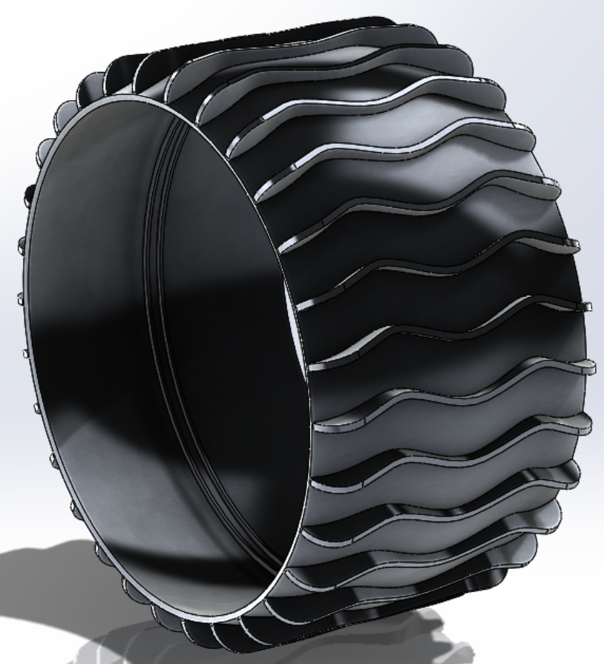

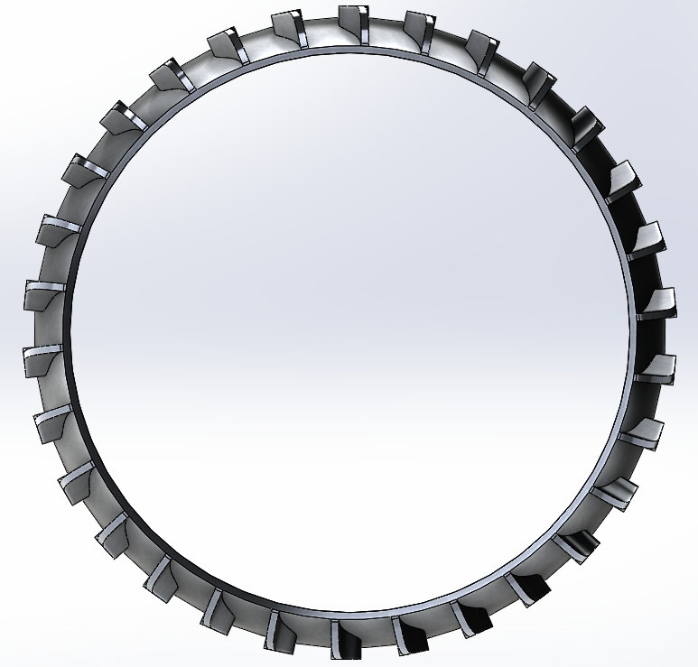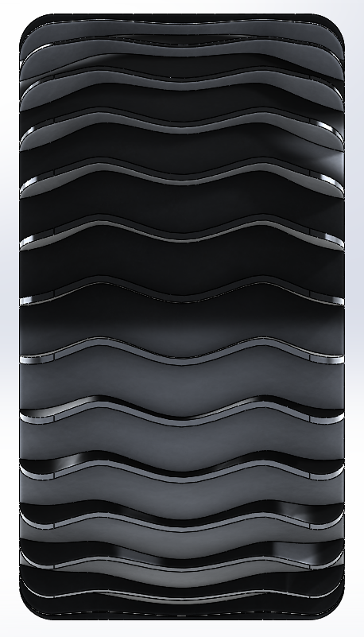

### Parameters

#### Main wheel

Diameter: [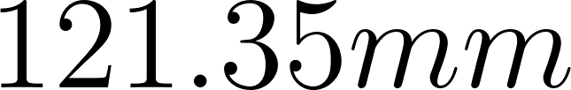](https://www.codecogs.com/eqnedit.php?latex=121.35mm#0)

Width: [](https://www.codecogs.com/eqnedit.php?latex=150mm#0)

Thickness: [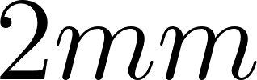](https://www.codecogs.com/eqnedit.php?latex=2mm#0)

#### Additional features

1. Height of grousers

*Variable; refer to section.*

[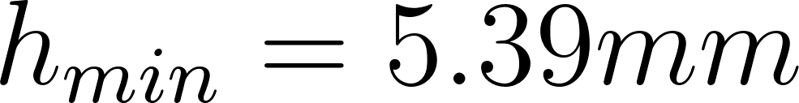](https://www.codecogs.com/eqnedit.php?latex=h_%7Bmin%7D%3D5.39mm#0)

[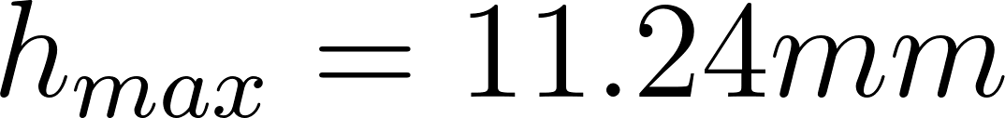](https://www.codecogs.com/eqnedit.php?latex=h_%7Bmax%7D%3D11.24mm#0)

1. Pitch

[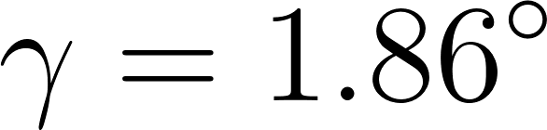](https://www.codecogs.com/eqnedit.php?latex=%5Cgamma%20%3D%201.86%5E%7B%5Ccirc%7D#0)

1. Profile of grousers

*Wavy spline profile, 2 periods. Amplitude of* [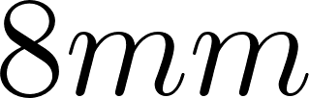](https://www.codecogs.com/eqnedit.php?latex=8mm#0)

1. Grouser spacing angle

[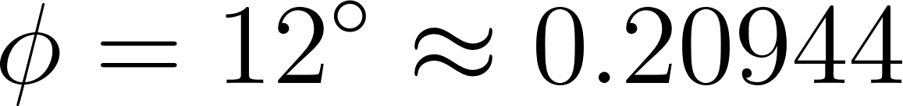](https://www.codecogs.com/eqnedit.php?latex=%5Cphi%20%3D%2012%5E%7B%5Ccirc%7D%20%5Capprox%200.20944#0)

1. Grouser chamfering (edge along longitudinal axis)

[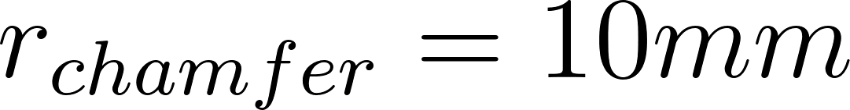](https://www.codecogs.com/eqnedit.php?latex=r_%7Bchamfer%7D%3D10mm#0)

1. ~

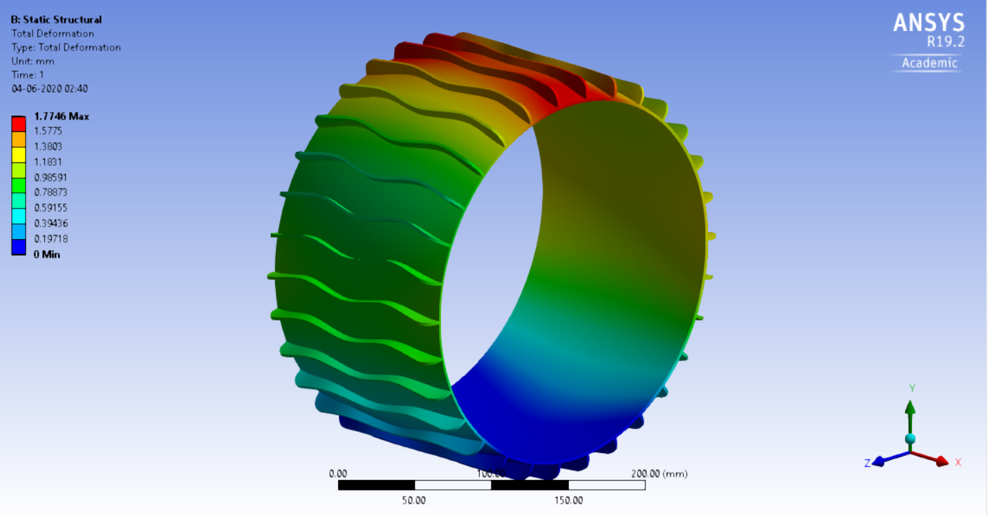

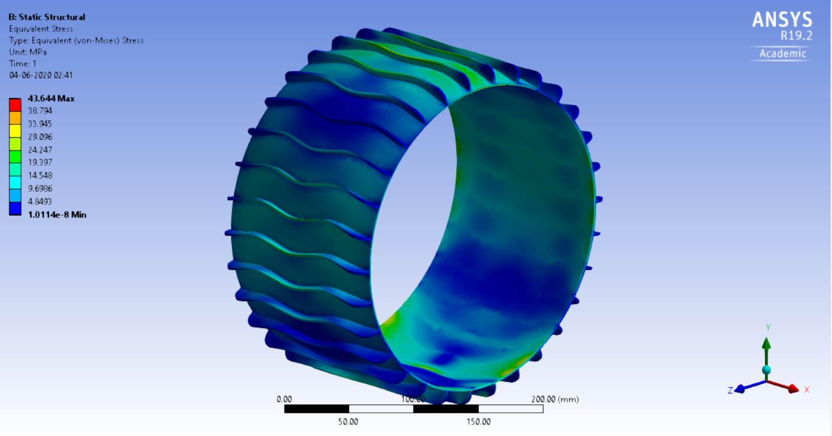

*Above:* Static structural analysis displaying equivalent stress with deformation in true scale. Load applied: [](https://www.codecogs.com/eqnedit.php?latex=100%20N#0)onto the uppermost face of the main body.

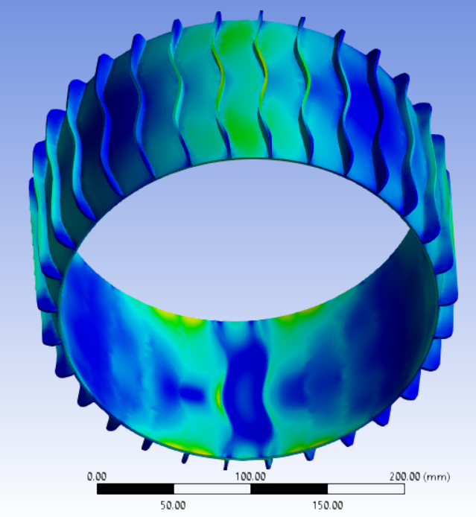

## NPT

### Design#1

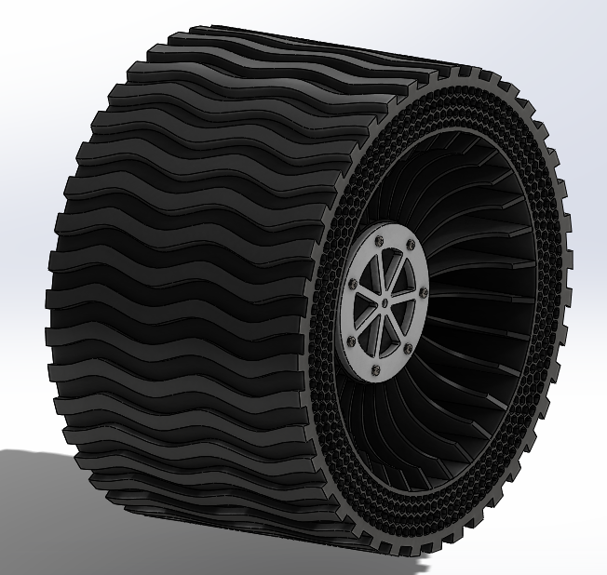

Honeycomb incorporation is done on the basis of literature studies [[1]](https://www.sae.org/publications/technical-papers/content/2019-28-0059/) [[2]](http://www.ijsdr.org/papers/IJSDR1901011.pdf), which claim the superiority of such structures over other features to be present closest to the outer shear layer. This design is not only robust and durable but also allows significant deformation, forming tank track-like interfaces with the ground localized to each wheel (similar to Galileo Wheels [[3]](https://www.youtube.com/watch?v=g_NmL44G2b0)). Grousers have also been suitably introduced, ensuring sufficient traction on rugged terrain. Material proposed for the main body is TPU (thermoplastic polyurethane) which can be 3D printed at the institute. The central hub in the depicted image above is made of ABS (acrylonitrile butadiene styrene) to ensure maximum rigidity and ease of manufacture. It can be replaced by an equivalent metal version if deemed necessary.

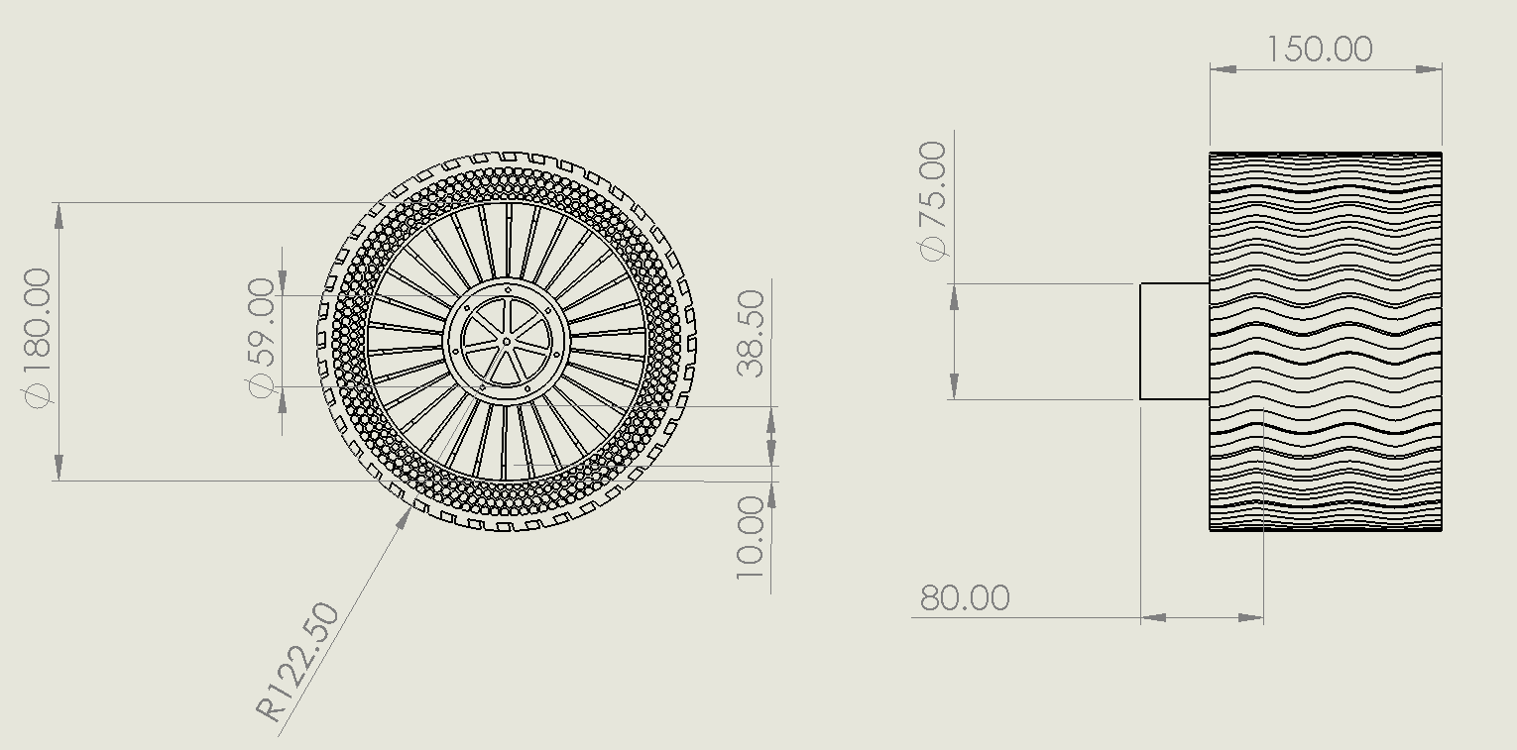

### Design#2

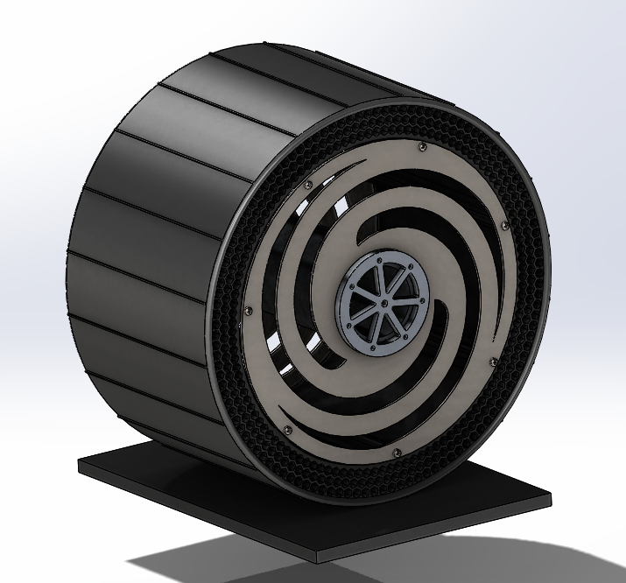

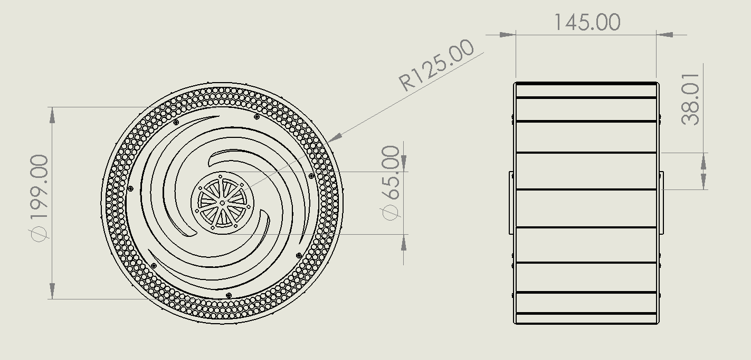

## 

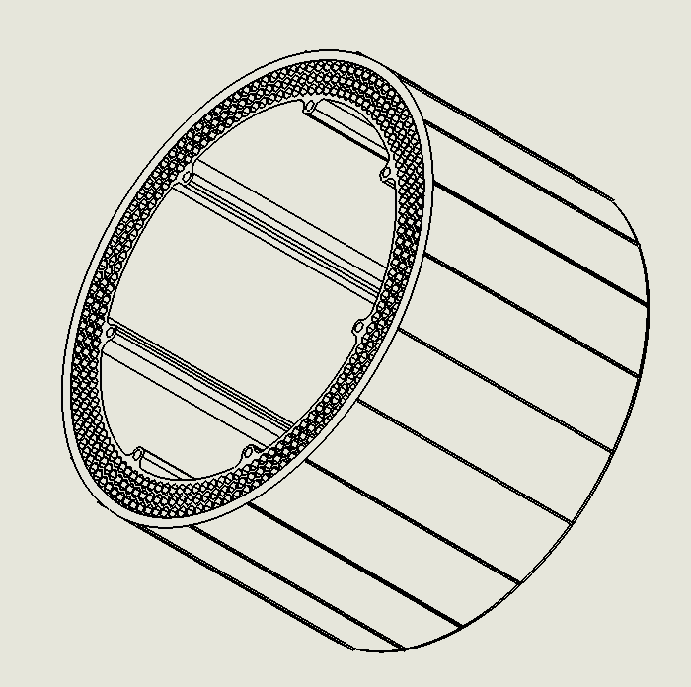

This design incorporates seven metal rods which run along the lateral axis, to provide more uniform load distribution to the honeycomb layers. It is affixed to two metal plates (thickness 2mm) which have a moderately shock absorbing design. This could be easily implemented using sheet metal, and hence is better than the spirals suggested in Metal Design#1, which would require laser-extrusion of a full billet of aluminum.

The simple and low-height straight grouser-like features on the tread are supported by literature for differential drive and for non-benign and yielding terrain [[4]](https://www.ri.cmu.edu/publications/analysis-of-grouser-performance-to-develop-guidelines-for-design-for-planetary-rovers/).

Weight: 3.4 kg

### Design#3

The #2 design was optimized further after meetings with other teammates. Some of the several improvements include encapsulation of the rim plate with the wheel tread, maximizing the contact area and ensuring optimal transmission of motor torque to the tread while being safely within the admissible bearing stress at the seven contact points. In view of weight reduction, the design of the intermediate region has also been modified to a floral structure.

The rim structure was also noted to be lacking from several perspectives and has been modified to create a lighter and safer design.

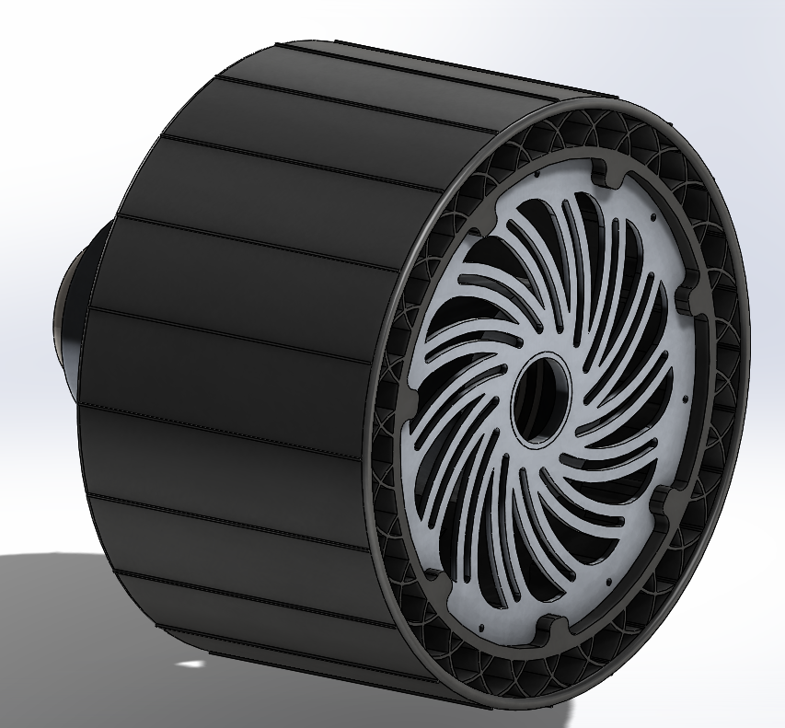

As the design was converging toward the final draft, the motor hubs have also been incorporated in this iteration, along with bearings fasteners. Other works include further optimizations carried out for decrease in weight.

Since the motor had also been chosen at this stage, the chosen motor was also recreated with an accurate mass and mounted on the assembly.

**Weight:** 2.4 kg

**Weight with motor:** 3.9 kg

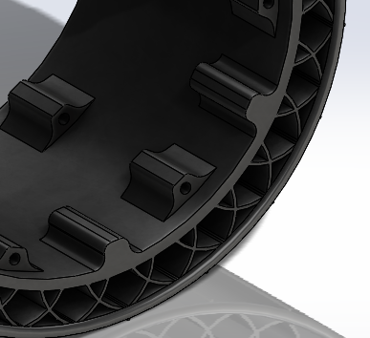

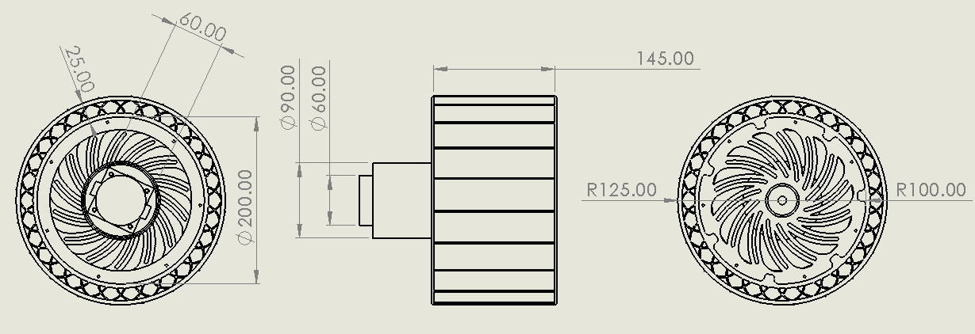

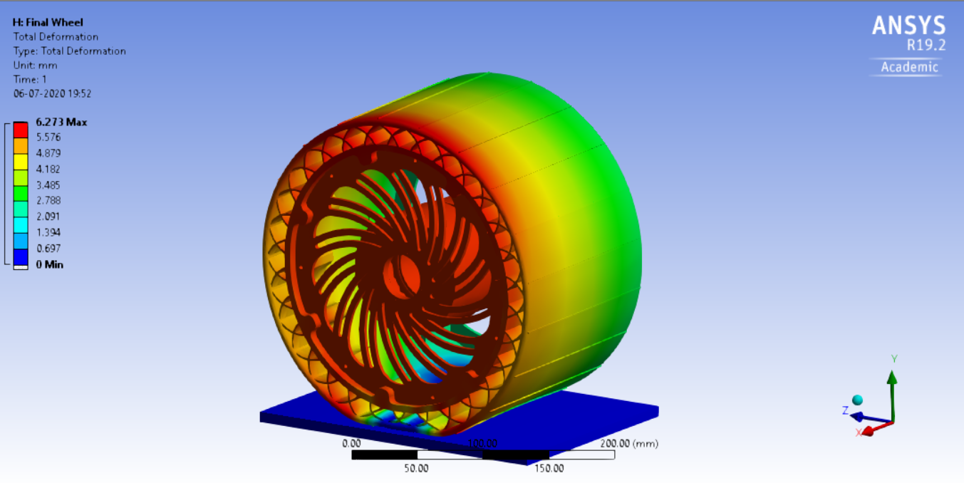

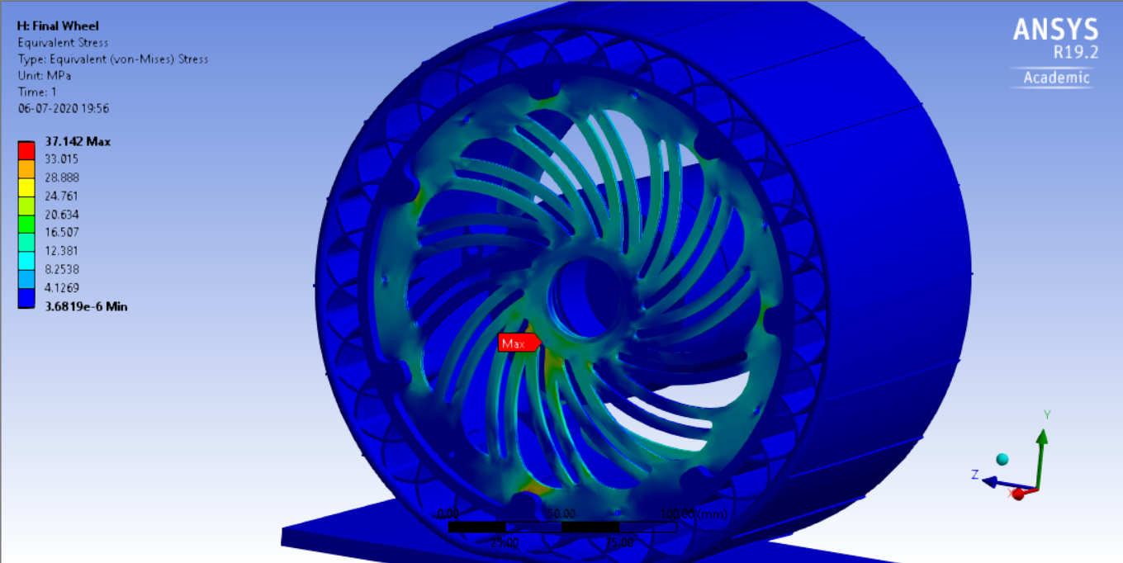  
The rim takes most of the stress in a distributed manner.

The stress peak

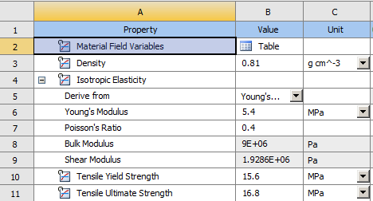

The material data assumed for TPU has been depicted above. Simulation results are subject to change with different grades of TPU and their respective shore hardnesses. Conducted simulation used loading of 333 N (FS ~4) under the assumption of six wheels.

The highest stresses are encountered at the flexure-hub connection, which is expected, and also at the tread-rim contacts. According to [literature](https://books.google.co.in/books?id=xiK3DwAAQBAJ&pg=PA155&lpg=PA155&dq=%22compressive+strength%22+tpu&source=bl&ots=ijw_WVS1Nv&sig=ACfU3U0jJ844ALEELj2tg_JXPtJkvTDCqw&hl=en&sa=X&ved=2ahUKEwjXwNea7bjqAhW6zDgGHa4FBaAQ6AEwDXoECAoQAQ#v=onepage&q&f=false), even the weakest grade of TPU can withstand compression fairly well, having a compressive yield of 2.6 MPa. The probed tread-rim contacts reveal a 1.066 MPa maximum principal stress transmitted to the tread, which seems well within the bounds, provided we have a high FS.

## Metal

### Design#1

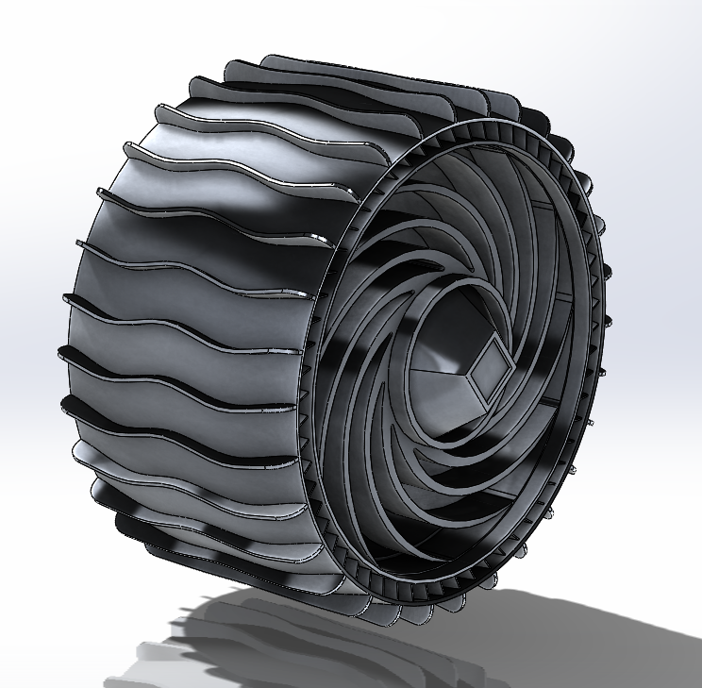

This design is largely based on the MER wheel while correcting almost fatal engineering flaws found in it after the commencement of operation on Mars. The traction was found to be very poor on sandy and yielding terrain in the original wheel (image below) and that has been changed with the introduction of larger grousers mimicking the shape of chevrons.

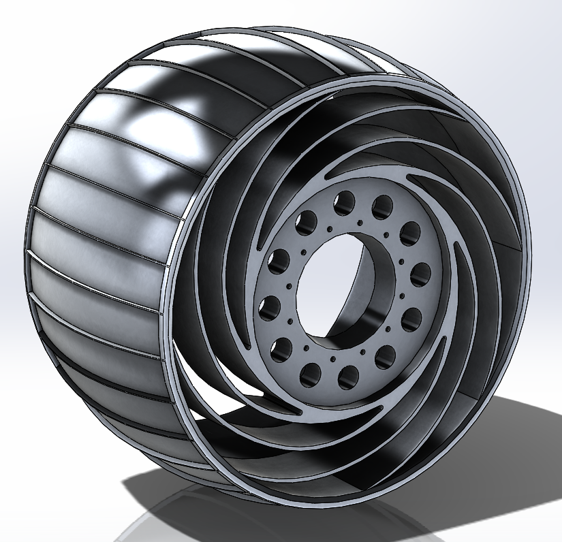

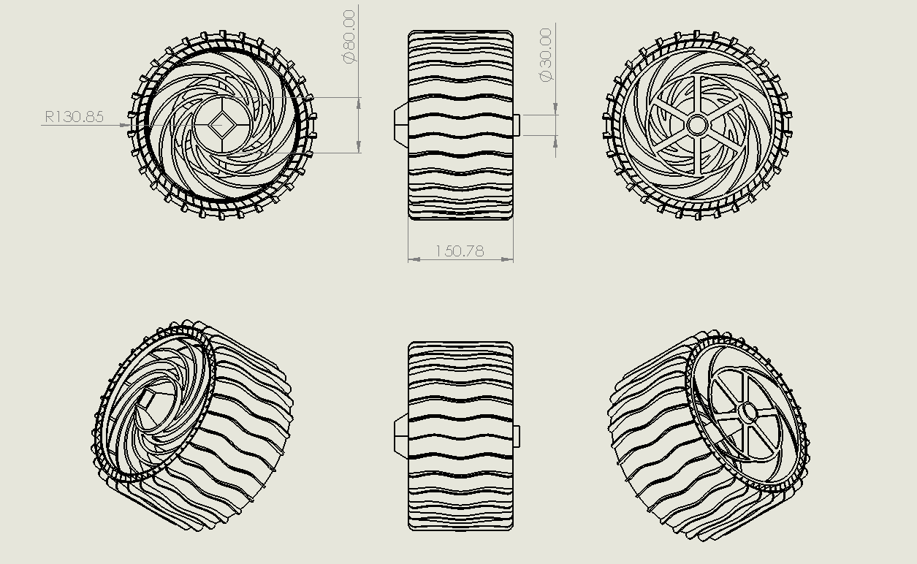

# Bloopers

*To be ignored by normal people*

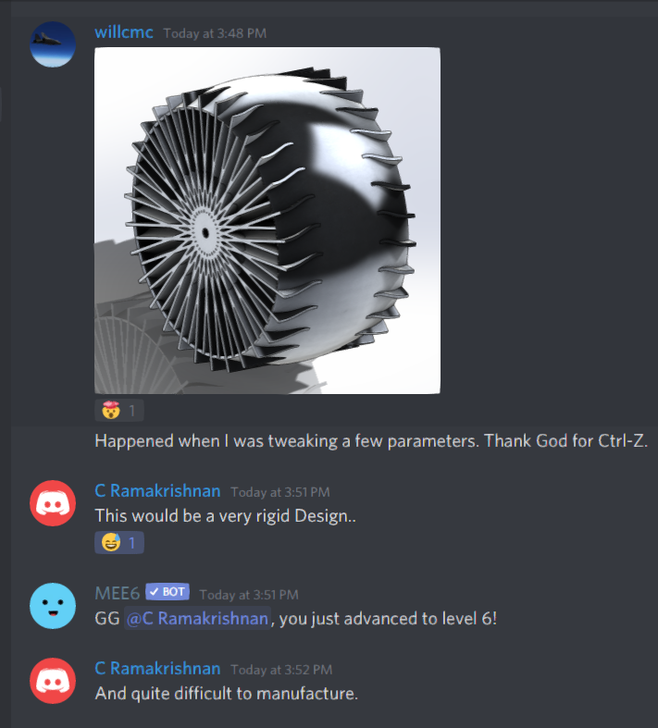

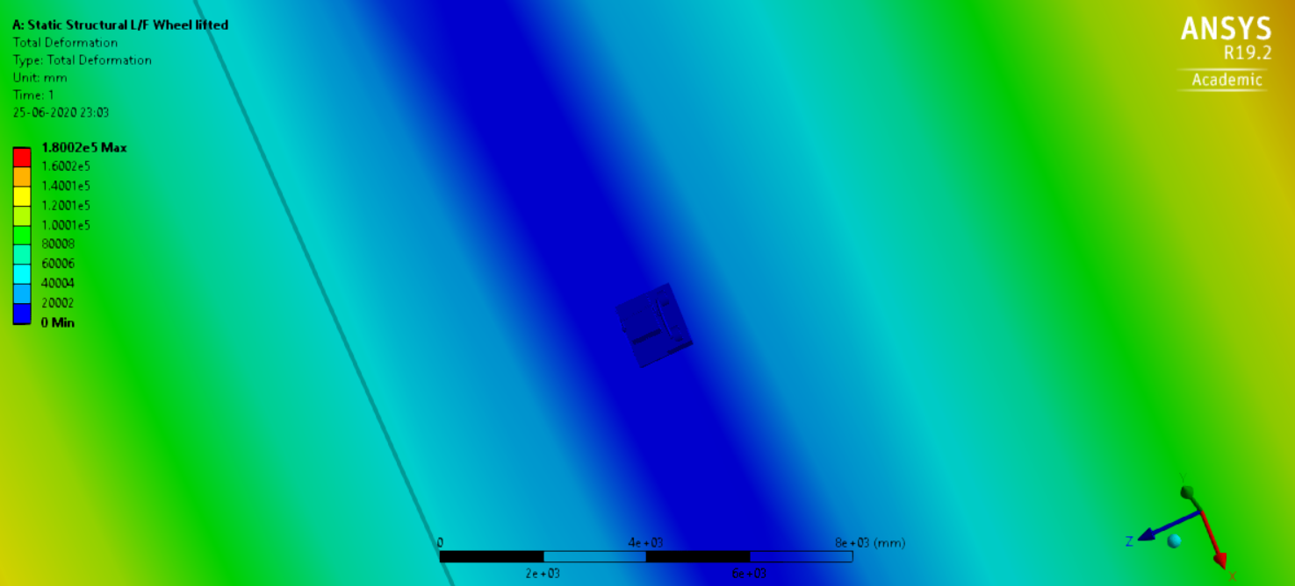

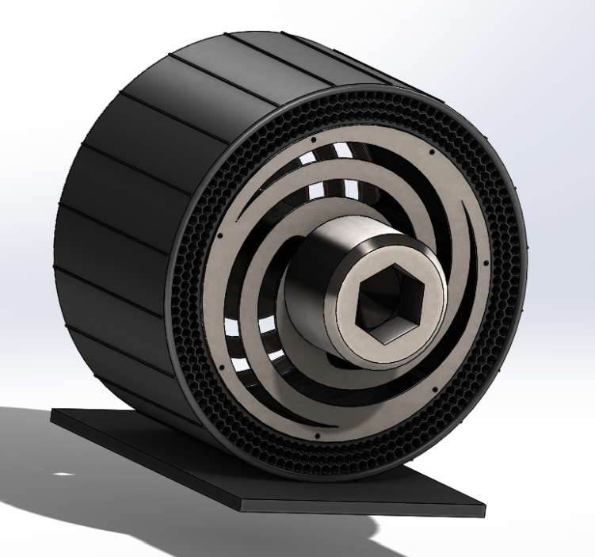

Too large a bolt?